How to obtain Proof of Delivery (POD) from Fedex and UPS

For Fedex:
1. Enter Fedex website：https://www.fedex.com/en-us/home.html
2. Enter your shipment tracking number and click Track.
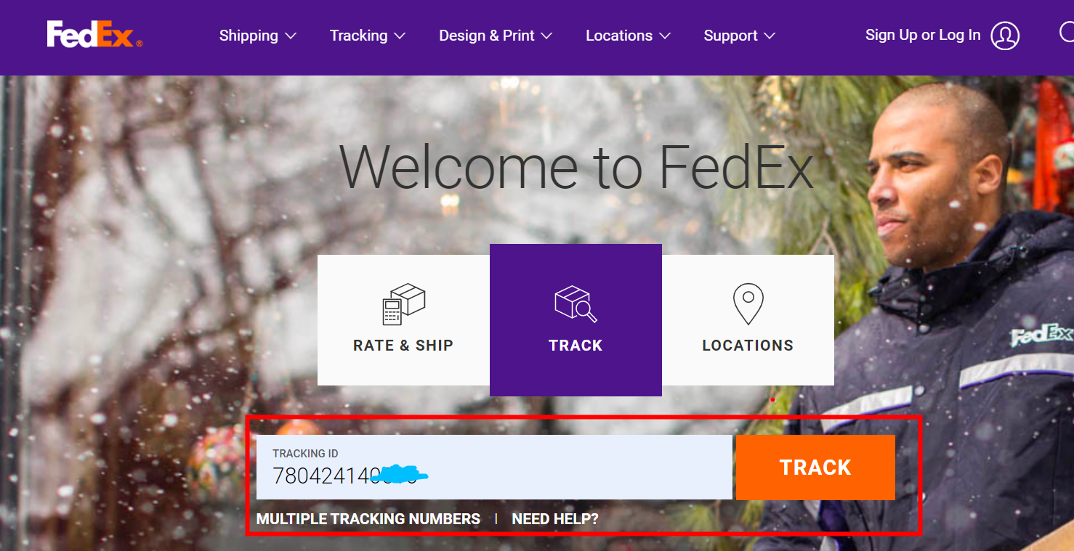

3. Click See full details.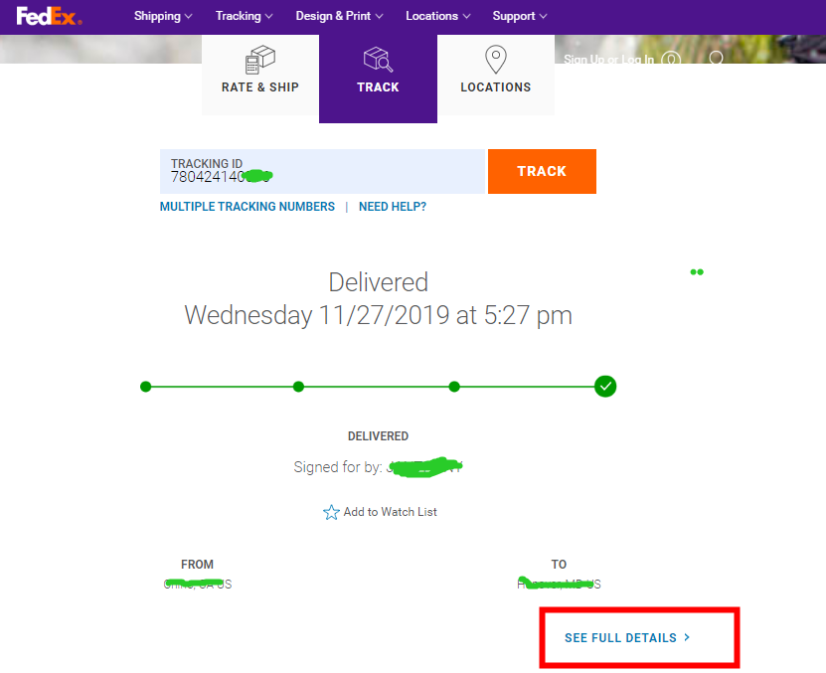

4. Click Obtain proof of delivery > Submit.

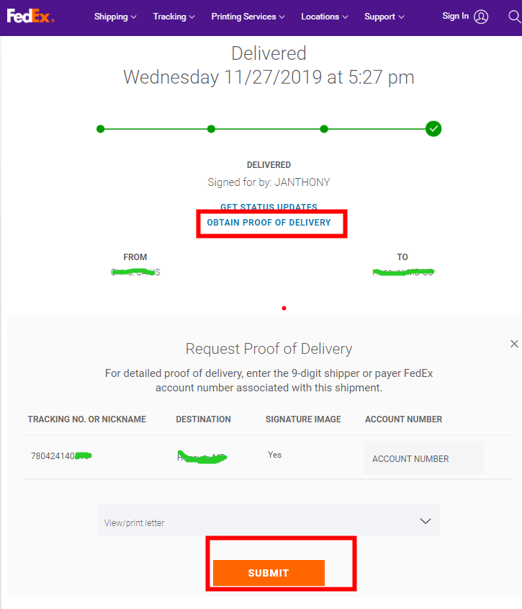
5. This is a sample of POD you’ll get：
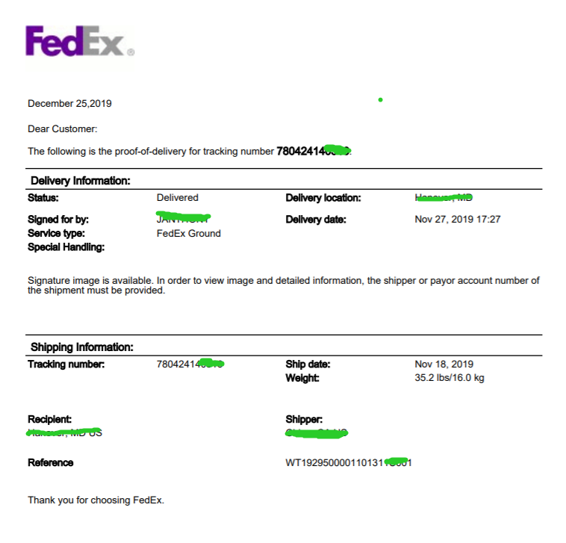
For UPS:
1. Enter UPS website: https://www.ups.com/cn/en/Home.page
2. Enter your shipment tracking number and click Proof of delivery.

